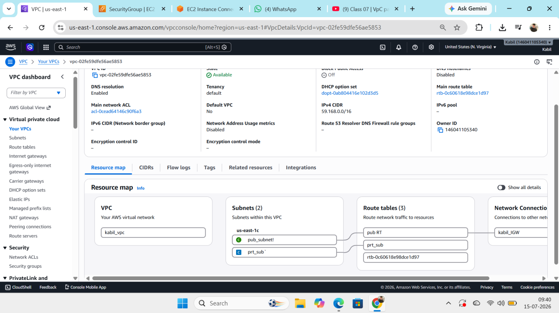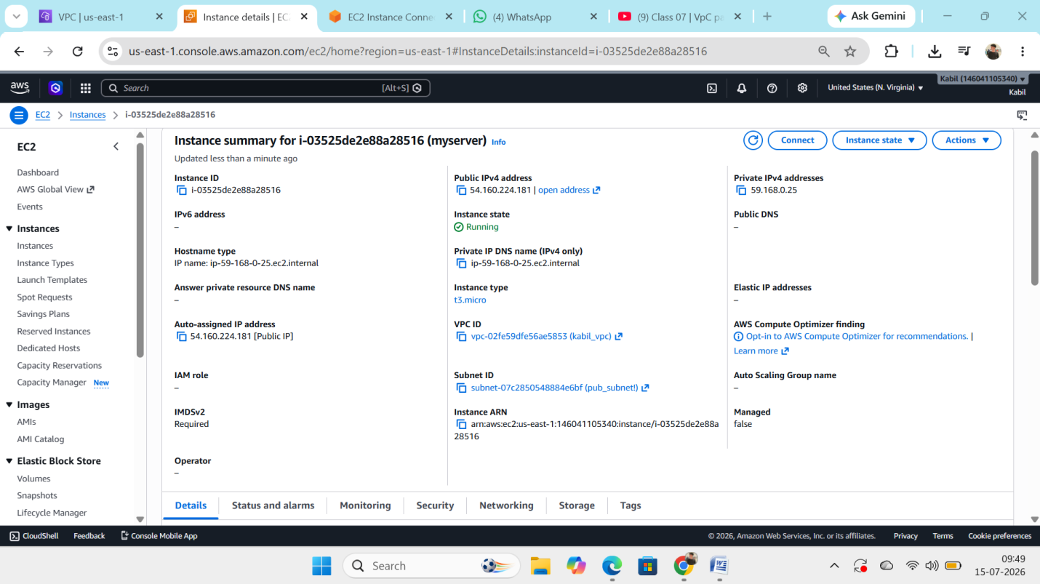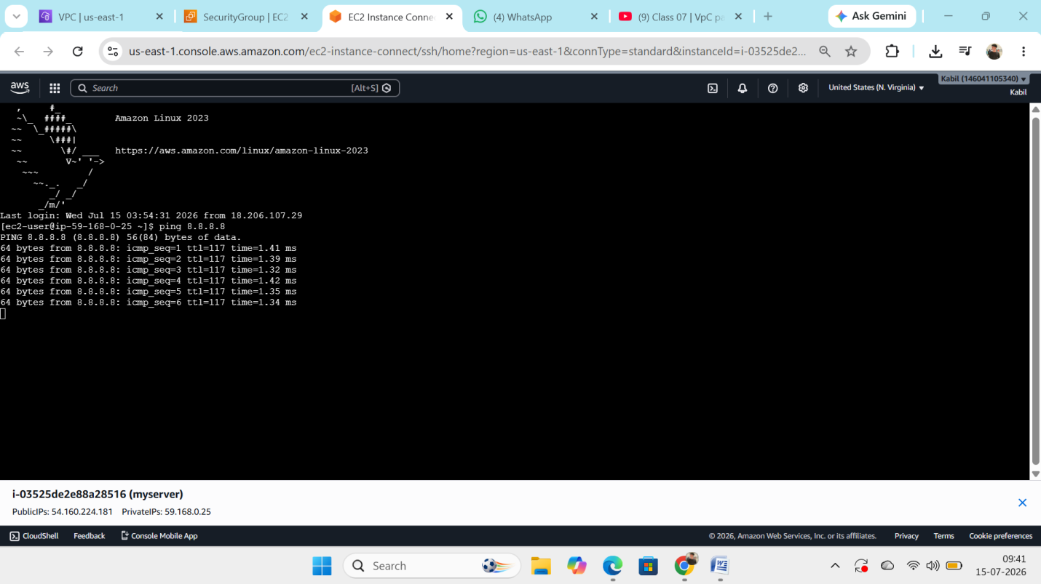

Step 1: Create a VPC
- Create a VPC with the CIDR block 59.168.0.0/16.

Step 2: Create Subnets
Create two subnets within the VPC:
- Public Subnet: 59.168.0.0/24
- Private Subnet: 59.168.1.0/24

Step 3: Create and Attach an Internet Gateway (IGW)
- Create an Internet Gateway (IGW).
- Attach the IGW to the VPC.

Step 4: Create Route Tables
Public Route Table
- 59.168.0.0/16 → Local (VPC)
- 0.0.0.0/0 → Internet Gateway (IGW)
Associate this route table with the Public Subnet.
Private Route Table
- 59.168.0.0/16 → Local (VPC)
Associate this route table with the Private Subnet.

Step 5: Launch an EC2 Instance
- Launch an EC2 instance in the Public Subnet.
- Enable Auto-assign Public IPv4 Address.
- Attach the appropriate security group (allow SSH from your IP).

Step 6: Connect to the Instance
- Connect to the EC2 instance using SSH via its public IP address.
- Verify internet connectivity by pinging Google's DNS server:
ping 8.8.8.8
ping is successful, the instance has outbound internet access through the Internet Gateway.

